**CS691 - Computer Science, Spring 2020**

**Project Initiation Document**

Project: **UnitFit**

Project Manager: Pratesh Gartaula

Start Date: 8/25/2020

Completion Date:

Table of Contents

Document Purpose 4

Background to the Proposed Work 4

Vision 5

Project Objectives 5

Project Scope 5

Business Case 5

Assumptions 9

Constraints 9

Risk Management Strategy 10

Deliverables 11

Stakeholders 11

Project Team 12

Project Plan 14

Project Controls 14

Communication Plan 15

Document Details

|  |  |  |  |
| --- | --- | --- | --- |
| Version | Modifications | Author | Date |
| 1.0 | Initial PID Document |  | 9/4/2020 |
| 1.1 | Project Plan, RACI, Vision, Stakeholders |  | 9/13/2020 |
| 1.2 | RACI, Stakeholders |  | 9/14/2020 |
| 1.3 | project plan, Business requirement, BRM, Context diagram |  | 9/20/2020 |
| 1.4 | updated BRM and update PID Production  Team section |  | 9/21/2020 |

Approvals

This document requires the following approvals:

|  |  |  |  |  |
| --- | --- | --- | --- | --- |
| Name | Role | Signature | Date | Version |
| Pratesh Gartaula | Project Manager |  | 9/8/2020 |  |
| Rohan Singh | Product owner |  | 9/8/2020 |  |
| Samarth Gowda | Lead Developer |  | 9/8/2020 |  |
| Dac Vu Ho | DBA |  | 9/8/2020 |  |
| Annet John | Lead QA Analyst |  | 9/8/2020 |  |
| Yuri Chernak | Professor |  |  |  |

Distribution

This document has been distributed to:

|  |  |  |  |
| --- | --- | --- | --- |
| Name | Role | Date of Issue | Version |
| Pratesh Gartaula | Project Manager |  |  |
| Rohan Singh | Product owner |  |  |
| Annet John | Lead QA Analyst |  |  |
| Samarth Gowda | Lead Developer |  |  |
| Dac Vu Ho | DBA |  |  |
|  |  |  |  |

# Document Purpose

Project Aim and Purpose:

‘**UnitFit**’ is a fitness application that provides easy and effective workouts for all Users. The application allows users to set their fitness goals and track their progress along their journey. Our users have various workout regimes to select from our handpicked workout programs. With the various programs, exercise tips, and diet plans, our application will be used as a tool for encouraging positive behavior change in the fitness industry. The application is scaled from Beginner level to Advanced level, making it accessible to every user. The intuitive design will make Users use the application more often as we will be providing user-friendly designs, making it easy to navigate and use.

Our purpose is to make our Users' workout regime easier and balanced. Any user can curate their exercises from our list of workout programs. The first few workout programs offer free services with one’s progress report tracking. There are advanced level exercises too; which focuses on each part of the body with extra tips, these programs are accessible only when you are a premium member. The program can be downloadable if the user wishes to use the application offline. Offline services will only be accessible when the user subscribes to one of the two Subscription models - Premium or Student.

In addition to our fitness application, we have a module that recommends a diet chart with meal preps according to the workout program you choose. These days it is tough to think and prepare your meals when you are on a diet, so the application offers various interesting low-calorie meal preps that can be prepared in no time and aids in weight loss.

Most of us work all day, and we hardly get time to take care of our bodies. So, while making this application, our team considered this and made sure that the duration of each workout program is less than 30 mins. Our goal is to make this application effective for Users to make them feel good while exercising and eat well-balanced food in a fun way through fitness.

# Background to the Proposed Work

These days, it is medically proven that those who do regular physical activities can lower cardiovascular diseases, some cancers, and the risk of diabetes up to 50% to improve quality of life and enhance the chances of living longer. People, especially millennia, are increasingly aware of the drawbacks of a sedentary lifestyle, however, time budget, weather conditions, physical distance can restrict regular physical activities and put forward a wide range of challenges to restrict people to reach their goals. Therefore, the specific requirements of daily workouts have received concerns, especially with the hustle and bustle pace of life aiming to balance between physical and mental health. Developing virtual alternatives for home-based classes with reasonably priced subscriptions, and among these, some are free, but the better one requires subscriptions to bring the users more qualified content.

With these prerequisites and key reasons, creating a workout application completely deals with the above issues and even be likely to create bigger values for users based on available resources, competitive strategies, and professional management.

# Vision

To profoundly improve the quality of life for millions of people by educating, inspiring, and providing the most effective, efficient, and safe exercise program.

# Project Objectives

The main objective of this proposed project is to help individuals to gain and maintain a healthy lifestyle anywhere irrespective of their locations. Since the project provides instant access to different workout videos, Nutritional tips, and Keeps track of the daily intake of food, it drastically reduces the time taken by an individual, if they had gone to work out to the actual gym. Also, this project aims to provide a smooth interactive interface for the end-users.

# Project Scope

The main purpose of the project is to develop an application that provides access to different health-related resources. Since the internet is becoming a global standard and its easy availability can make this project revolutionize the Gym Industry by not attracting potential customers. The main benefit of this project is for trainers who create video content.

This project has both functionality and aesthetic requirements. It is very much necessary to address some particular needs:

* A Sign-up or a login page to sign in into the application
* A list of workout videos which is sorted by different level of difficulty ( Beginner, Intermediate, Advanced)
* A list of Nutrition tips and guides for the user to maintain a healthy lifestyle
* A daily intake tracker is to help the users to track and store their daily food intake for days, which makes it easier to compare and achieve their goals.
* Based on the location of the user, we can try to find the nearest available trainers around them to hire a Personal Trainer.

# Business Case

|  |  |
| --- | --- |
| **Application Name** | **UnitFit** |
| **Type of business model** | **Examples:**  **Direct sales, platform, etc. See the document "Types of Business Models"**  Freemium and Subscription model |
| **The target audience of external users**  **(Customer Segments)** | **For whom are we creating value?**   * For all Users   **Who are our most important customers?**   * Open to all * Gym enthusiasts * Users who would like to workout at home. |
| **Groups of internal stakeholders, users** | **Do we need a product development group?**   * No   **Do we need a sales group?**   * Yes   **Do we need a finance group (accounts payable, receivable)?**   * No   **Do we need a customer support team?**   * Yes, we will try our best to make the interface user-friendly.   **Do we need an advertising management group?**   * Yes   Internal Stakeholders:  Team Members, Product Manager, Sales Team, Advertising Team |
| **Value propositions** | **What value do we deliver to the customer?**   * Any Customer will find it easy to use the application as there are three different levels for the user to choose from – Beginner, Intermediate, and Advanced. * The application even helps to regulate a healthy diet while doing the workout regime.   **Which one of our customer’s problems are we helping to solve?**   * These days we find customers have a hard time choosing which exercise is good and effective and could be achieved in a short amount of time, our application has various workout programs to select from, the exercises from easy to hard levels. Each workout program is designed for less than 30 mins to save a user’s time.   **What bundles of products and services are we offering to each Customer Segment?**   * Free Services: (Freemium)   + Access to the main dashboard, where users can start with any of the three levels – Beginner, Intermediate, or Advanced with workout videos.  + Access to the Report Card (Progress of your growth)   * Subscription Model:   + Advanced levels have exercises that focus on each part of the body and have extra tips given to the User.  + According to the selected workout program, there will be a diet planned out for the User or there is an option for the user to select from the list of meal preps.  + Premium Member - $12.99/month (all services included)  Student Member - $6.99/month (all services included)   * Seasonal promotions and offer discounts will be available for all subscribed members.   **Which customer needs are we satisfying?**   * We are solving the need for a user not to go out his/her way to find a specific Workout regime or a Workout schedule, which gets stressful. So, the application helps users to get access to easy and effective workouts in no time. |
| **Key resources** | **What Key Resources do our Value Propositions require?**   * Computer Power - Front-end Development, Back-End Development, and Database.   **Our Distribution Channels?**   * The Internet   **Customer Relationships?**   * Getting Customer Feedback and increasing offers and discounts to the existing customers.   **Revenue Streams?**   * Consumer Services, Consulting |
| **How the system is used** | **What are the main business use scenarios?**  The application is open to all. **UnitFit** is a one-stop destination in finding your workout goals. The application offers a set of workout programs for a user to select from. Many workouts take 30 mins or less and require minimal or no equipment.  It enables Users to access full fitness programs or mix and match your favorite workouts to build your program.    The application gives you access to incredible exercises that can be done by any user at any time of the day. To help the User track and train his/her food habits, the application brings about different interesting easy to make meal preps in no time (as time is the major constraint for most users). Adding a meal preps in the application helps the user to track what they need to eat and how to maintain their diet during their fitness journey.  To gain access to Advanced level workout programs, the user has to subscribe to one of the two subscription models - Premium or Student Member.  A subscribed member gets to download videos and workouts and use them offline.    Our application is user friendly as workouts programs are categorized into three levels:  Beginner, Intermediate and Advanced level (with training workout videos)  A progress report will help the user to be motivated and not lose track of the schedule.  **UnitFit** ensures customers get customized nutrition plans with our curated low-calorie meal preps, which are the latest recipes in the market. |
| **Revenue generation, Revenue streams** | Monthly User Subscription  Advertisement |
| **Key Partners/Suppliers**  **(Stakeholders)** | * Gym equipment brands * Supplement and Sports nutritions brands (MTS Nutrition, Core Nutritionals, Athletics Xtreme) |
| **Expected Benefits** | Monthly Subscription Revenue |
| **Known Prototypes** | **Reference some known portals on the Internet that are similar to your business case. You will use these prototypes for developing business, user requirements.**   * Beachbody workout:   <https://play.google.com/store/apps/details?id=com.beachbody.bod&hl=en_US>   * Cure fit:   <https://play.google.com/store/apps/details?id=fit.cure.android&hl=en_US> |

# Assumptions

This section will include assumptions made before the requirements specifications have been documented. It may look something like this:

|  |  |  |  |
| --- | --- | --- | --- |
| Assumption | Validated by | Status | Comments |
| Project Resources | QA analyst | In process | Analysts will verify all resources and devices bi-weekly. |
| Weekly meeting | Project Manager | Completed | PM will make sure to schedule a weekly meeting and monitor each member task and direct them for the proper deliverable result |
| Participation Time  ( Extra 5 hr/week) | All members | Completed | All members will give at least 5 hr per week for the project. |
| Technology Consistency | Business Analyst | In process | Business Analysts will inform all teams about any update on the latest technologies for our better product. |

# Constraints

* Agreeing on terms with suppliers for distribution or receiving products
* To make our application run in both operating system (IOS and android) can be quite challenging
* Most of the team members have either internship or part-time jobs during the weekdays, so arranging the specific time for all members is challenging

# Risk Management Strategy

Financially, risk management plays a pivotal role in the success of the project. Risk is likely to be either an event or an activity potentially happening in the future and having effects on the project. Identifying, analyzing, planning, and monitoring the risks enable a firm to define its objective, empower the business with necessary tools and prepare for eventualities that may come in the way of progress and growth. Risk management can be described by the diagram included four stages as follow:

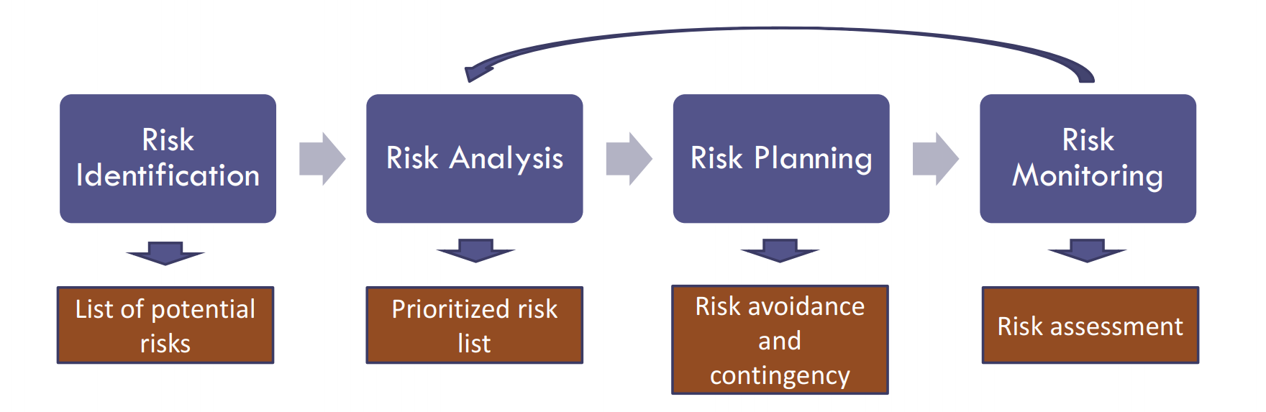

* Risk identification: specifying the possible uncertain events that could affect the project outcome.
* Risk Analysis: analyzing the probability of occurrence of the risk and its possible impact (Qualitative) on the project outcome based on the numerical analysis.
* RIsk Planning: deploying necessary strategies for possible and probable risks to either increase the positive effect or mitigate the negative consequence.
* Risk monitoring: performing all the above steps/ identifying new risks/ evaluating risk process effectiveness throughout the project.

|  |  |  |  |
| --- | --- | --- | --- |
| Risk | Probability | Impact | Mitigation Method |
| Resource shortage (lesson plans, videos, images) | High | High | Buying the copyright from other sources. Referring to some online documents and redesign. |
| Insecure data storage | High | High | Developing an additional layer encryption |
| Low revenue | Medium | Medium | Optimizing the App Ads to reach the audiences |
| Skills | Medium | Medium | Team members recognize the necessary skills for the project, swap responsibilities, and improve their skills if needed |
| The excessive cost of hosting plan, maintenance fee | Low | Low | Finding some companies can offer free hosting services. |

# Deliverables

This section should include the main deliverables and outcomes the project is expected to achieve. It may be presented in the following format (see the project delivery schedule on Blackboard):

|  |  |  |
| --- | --- | --- |
| No | Artifact Name | Responsible Party |
| 1 | Project Proposal | PM |
| 2 | PID Document | PM |
| 3 | BRM Diagram; User Roles | Product Owner |
| 4 | Context Diagram; System Interface Table | Lead BA |
| 5 | Architecture Diagrams (Logical, Process views | Lead Dev/DBA |
| 6 | Business Requirements | Product Owner |
| 7 | RCT (includes func. decomp., suppl. reqs) | Lead BA |
| 8 | Use-Case Diagrams (UML) | Lead BA |
| 9 | Activity Diagram (UML) | Lead BA |
| 10 | Data-flow diagrams (logical, physical) | Lead BA |
| 11 | Functional Requirements (user stories) | Lead BA |
| 12 | Class Diagrams | Lead Dev |
| 13 | Sequence Diagrams | Lead Dev |
| 14 | Entity Relationship Diagram (conceptual, logical) | DBA |
| 15 | Table Specifications (Data Dictionary) | DBA |
| 16 | Source Code sample (part of Demo) + GitHub repository slides (images) | Lead Dev |
| 17 | Test Plan document | Lead QA |
| 18 | Presentation, Application Demo | ALL |

# Stakeholders

This section will include a list of all known stakeholders and their interests in the project. It may be presented in the following format:

|  |  |
| --- | --- |
| Stakeholder | Interest |
| Product Team | Teams will be performing the tasks and producing deliverables each week according to the project plan schedule and participate in the Project Manager’s communication channel. |
| Project Manager | Establishing a healthy Project plan with the team and managing the team’s performance of project tasks and will handle the approval of deliverables each week performed by various stakeholders. |
| Sales Team | Using Google ads and free subscription for a short period of time when the customers purchase the products from other partners. |
| Product Development Team | Implementing strategy, building the roadmap, and defining product features. |
| Finance group | Making payments to outside partners for goods or services. |
| Advertising Team | Helping to inform consumers and business customers about the company's products and services. |
| Customer Support Team | Identifying customer needs and helping customers use specific features. |

# Project Team

The project team includes the following roles:

* Project Manager - Pratesh Gartaula
* Product Owner - Rohan Singh
* Lead Developer - Samarth Gowda
* DBA - Dac Vu Ho
* Lead QA Analyst - Annet John

Roles and Responsibilities of the team roles are defined in the RACI Table below:

|  |  |  |  |  |  |  |  |
| --- | --- | --- | --- | --- | --- | --- | --- |
|  |  | **Project Roles** | | | | |  |
| **Process Area** | **Project Tasks** | PROJECT MANAGER | PROD OWNER | DEV LEAD | LEAD DBA | LEAD QA | BUSINESS ANALYST |
| Project Management | Develop a project plan | A,R | R,C | R,C | R,C | R,C | R,C |
| Provide cost estimate | A | R,C | C | C | C | R,C |
| Hire resources | A,R | R,C | R,C | R,C | R,C | R,C |
| Establish a project portal on SharePoint | A,R | R | I | I | I | I |
| Maintain a project risk and issue log | A,R | R | C | C | C | C |
| Provide project status reports | A,R | R | I | I | I | I |
| Requirements | Perform requirements analysts | A,R | R | C | C | C | R, C |
| Gather business requirements | A | C | I | C | I | R |
| Produce functional requirements | A | I | C | C | C | R |
| Design | Produce high-level design specs | A | I | R | R | I | C |
| Produce data model | A | I | C | R | I | C |
| Produce detailed design specs | A | I | R | R | I | C |
| Coding | Establish a code repository | A | I | R | I | I | I |
| Develop component code | A | I | R | I | I | I |
| Testing | Develop a test plan | A | I | C | C | R | C |
| Establish a test repository | A | I | C | I | R | I |
| Develop test specifications | A | I | C | I | R | I |
| Execute testing, report defects | A | I | I | I | R | I |
| Conduct defect review calls | A | I | C | C | R | R |
| Produce, deliver defect metrics | A | I | C | I | R | R |
| Support test environments | A | I | R | R | C | C |
| Deployment | Produce a deployment plan | A | I | R | R | I | I |
| Produce deployment procedures | A | I | R | R | C | I |
| Deploy software into production | A | I | R | R | C | C |

# Project Plan

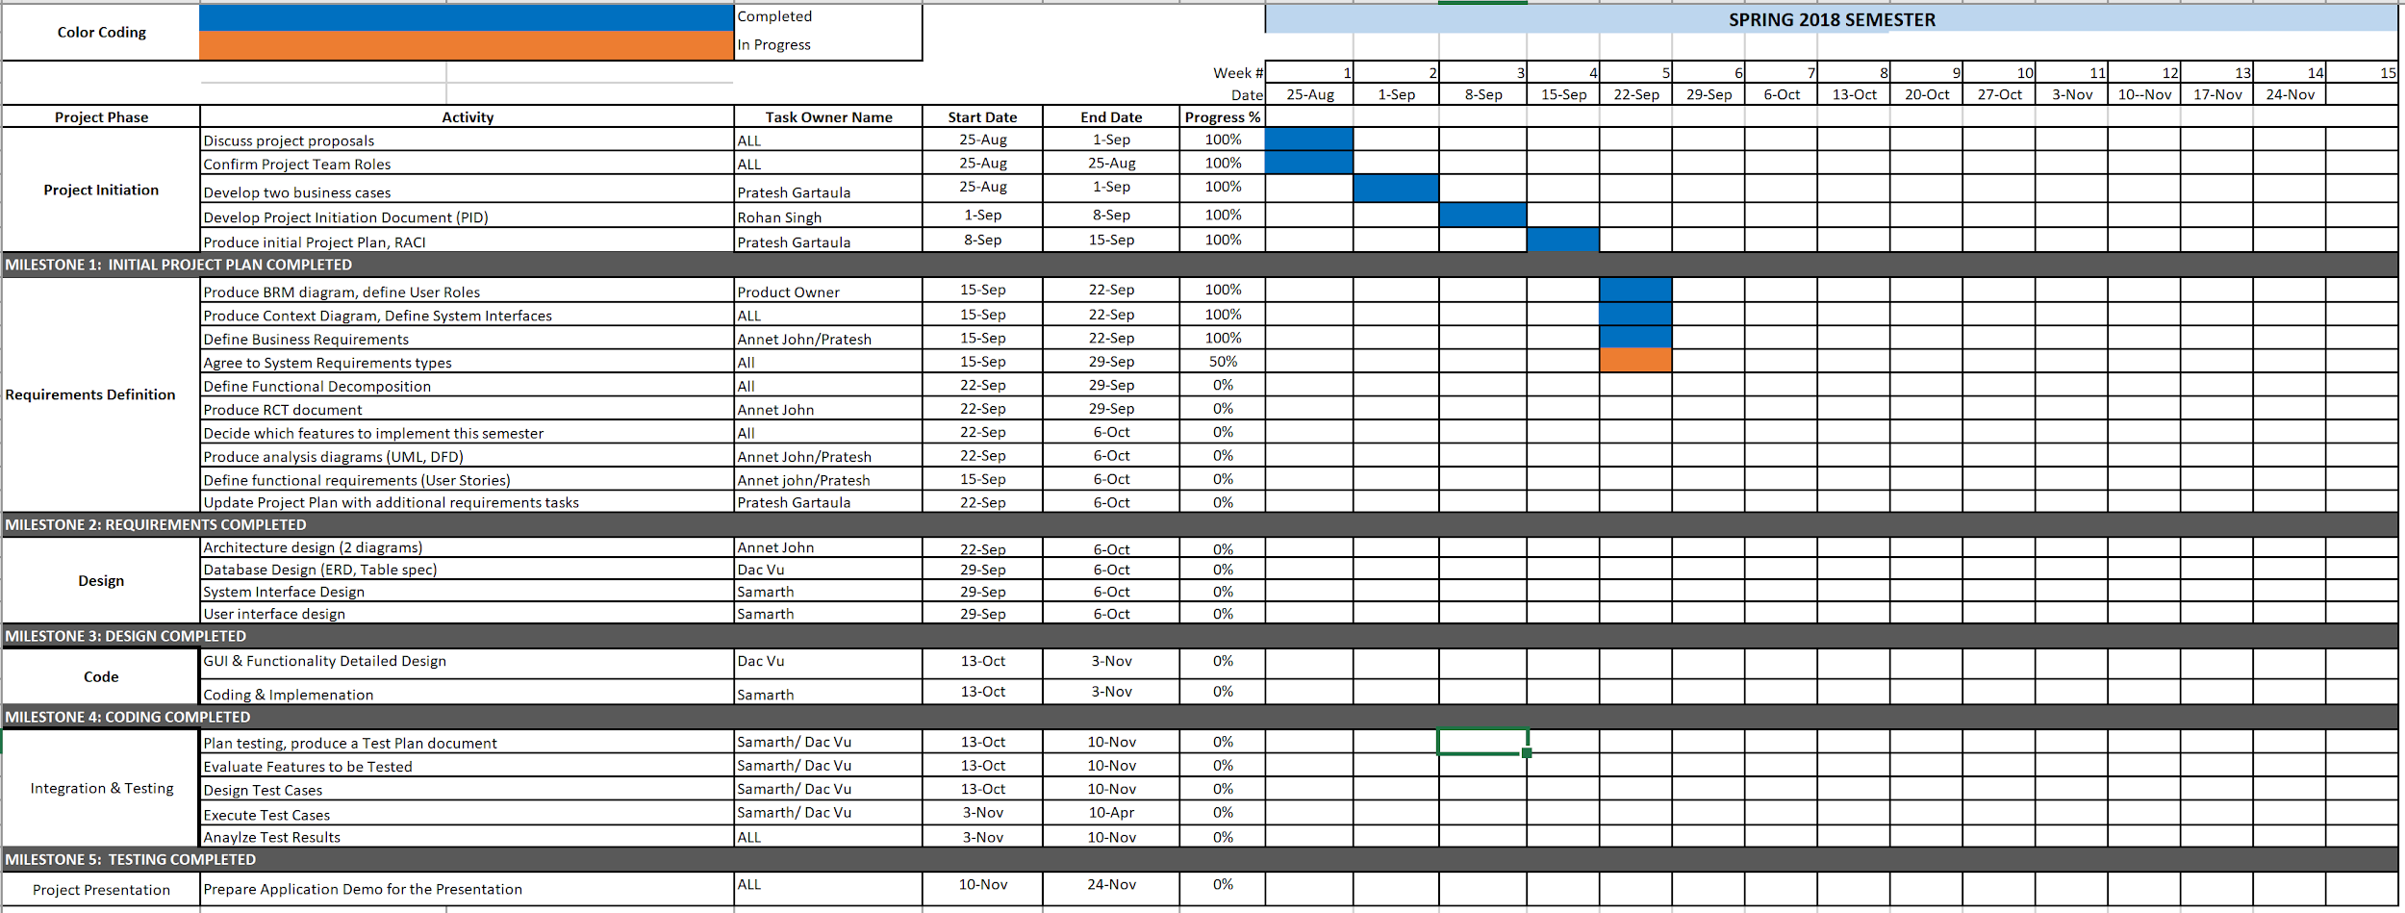

# Project Controls

* The Project Manager will conduct at least one weekly meeting and allowed every team member to express their ideas and any issues regarding their assigned task
* All members have to report Product Manager on the status of their world and should complete in a given one week frame unless specified.
* All team members are strongly encouraged to participate in the weekly meeting and let him know if he/she cannot join the meeting at least 1 day prior so that the PM rearrange or reschedule the meeting.
* All team members along with the Project Manager will discuss each week’s deliverable about how and who will be performing the certain division of responsibilities to advance to the further phases. The Project Manager will keep track of all the performance and deadlines of the task to make a smooth run of the project development.
* The team will use google drive for updating, editing, and monitoring the information as required and the Project Manager is the one who will share the link for google drive for team collaboration.

# Communication Plan

This section will include how stakeholders will be communicated with during the project and how frequently. This should include a note on where to find the Communications Plan if you have one.

|  |  |  |  |
| --- | --- | --- | --- |
| Stakeholder | Frequency | Type | Purpose |
| Team Member | Daily |  |  |
| Project Manager | Daily | Email, phone, skype, Zoom | For discussing on team’s progression and any issues during the project deliverables timeline |
| End users | During the testing phase | Email | to collect any suggestions or feedback |
| Suppliers/distributors | Daily | Email, Phone call | To establish expectations for reporting and run proper supplier communication |